**A2-1: Basic Command Line**

* Get help with the IPConfig utility

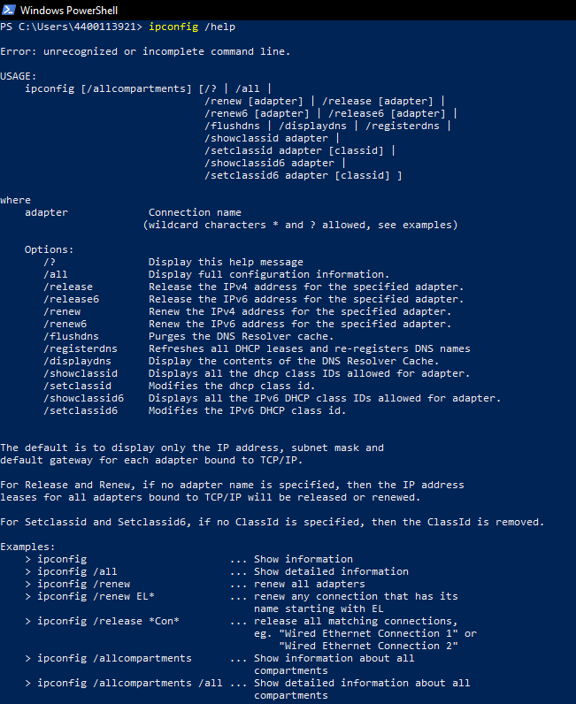

* Go to your user's Document folder

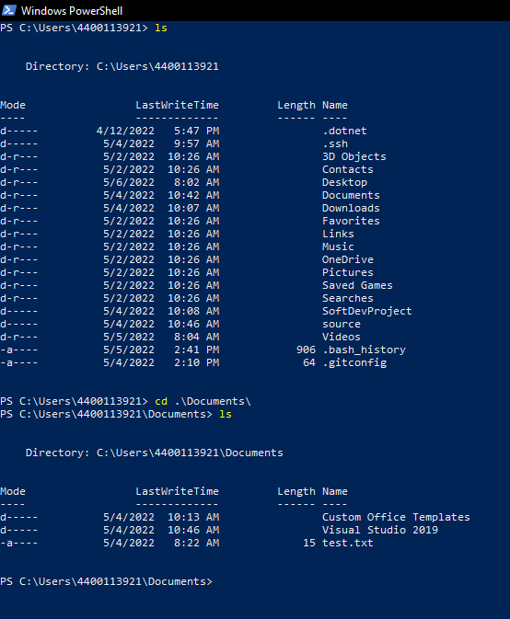

* Copy a file to another location
* This file can be a blank text file if needed
* Move a file to another location
* Make a directory in your user's folder (For example C:\Users\MyName\ everyone will have a different user directory inside Users)
* Install Git and add it to the PATH variable
* https://git-scm.com/downloads (Links to an external site.)
* This may be done automatically. If the path exists or Git is already installed, just take a screenshot of the Git binary in the PATH.